[](http://www.brethrentraining.org/)

## 'We Proclaim the Word of Life'

### Preaching the New Testament today

### Edited by Ian Paul & David Wenham

### Published by IVP

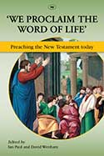This recent book edited by two excellent NT scholars (Ian Paul and David Wenham) tackles issues surrounding how we preach the NT today. The introduction is helpful in setting the scene and raising some of the challenges of preaching while positively affirming the importance and need for good exposition of the NT texts.

I haven’t yet read though the whole volume but looked at two of the essays it contains: that on the general epistles, and that on Revelation (as I am teaching or preaching from 1 Peter and Revelation in the near future). Both of these essays give helpful pointers to how to preach from the texts without getting bogged down in too many details concerning authorship, historical context etc. The commentaries cover these issues in detail and should be the first port of call for such discussions. These essays are more ‘practical’ and useful for those of us who are engaged in the task of preaching.

In tackling the seven catholic letters in one essay, Mariam Kamell had a difficult task and so her treatment of each letter is, necessarily, somewhat brief. However, the general comments she makes are very helpful and remind us that we have a responsibility to preach these letters as much as we have to preach those of Paul – which have in evangelical circles received a much higher profile.

Ian Paul’s discussion on Revelation owes much to his writing elsewhere, especially his extremely helpful [Grove booklet](http://www.grovebooks.co.uk/cart.php?target=product&product_id=16245). However, one section he adds is on possible preaching series on Revelation, recognising that a ‘traditional’ verse-by-verse exposition is probably not the best way to deal with this fascinating book.

Having read these two chapters, I am looking forward to reading the rest – as time allows!!!

## He began with Moses

### Preaching the Old Testament today

### Grenville J R Kent, Paul J Kissling and Laurence A Turner (Editors)

Published by IVP

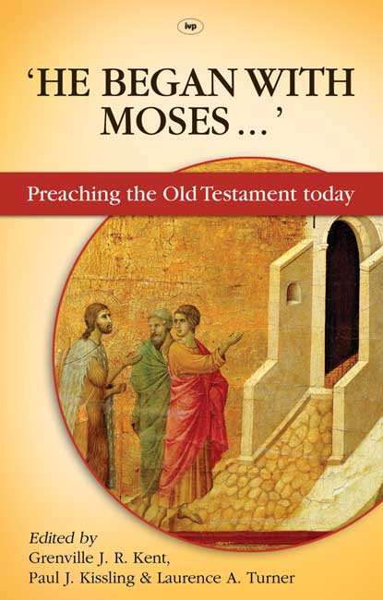In a companion volume to '*We Proclaim the Word of Life*', a number of Old Testament scholars and preachers have contributed essays on preaching the Old Testament story. 78% of the Bible is in the OT but it is, in very many ways, a neglected section - especially in preaching.

There are helpful chapters, especially if you have never studied literature to any degree, on the importance of both plot and character in narrative and how to use these as ways into texts.

The chapter by Ernest Lucas on preaching apocalyptic literature is very helpful, and worth looking at when preaching from Revelation. Daniel Block's treatment of Ezekiel is especially helpful. It is detailed and deals with seven basic propositions that are necessary for anyone wishing to repack from one of the most fascinating - but least understood - books in the Bible.

Gordon Wenham has a chapter on preaching from difficult texts in the OT where he considers some of the issues surround the law of talion, violence and the first 11 chapters of Genesis amongst others. As always, his comments are lucid and encouraging showing again his depth of scholarship along with the desire for the Bible to be well communicated from the pulpit.

The final chapter in the book is, fittingly for a book which takes Jesus' words to the disciples on the way to Emmaus as its title, on preaching Christ from the Old Testament by R. W. L. Moberly. This is a thought-provoking chapter which reminds those of us who preach that we have to see the OT through the 'lens' of the life of Christ if we wish to make our preaching both true to Scripture and relevant to our hearers.

Reviewed by Simon Marshall Dec 2013